GROUP 15

**Client Side Scripting**

**Part- B**

* PART- B
* Rationale

This project is developed for banking management. In this project we used JavaScript, HTML and CSS languages. This project is well developed using JavaScript Functions, Event Handling, Arrays, Cookies, Regular Expression and User-Friendly Interface (menus and navigation). The data from the forms is directly sent to Bank Mail using mailto feature. We tried to make it real as much as possible. Finally, we got this project done with desired output.

* Course Outcomes Addressed
* CO1: Create interactive web pages using program flow control structure
* CO2: Implement Arrays and Functions in Java Script
* CO3: Create event-based web forms using Java Script
* CO4: Use JavaScript for handling cookies.
* CO5: Create Interactive webpage using regular expressions for validation
* CO6: Create Menus and Navigations in web pages
* Literature Review

This project covers all the COS of Client-Side Scripting Language. We developed this project to understand various features of JavaScript and also to revise the concepts of HTML. This project is an example of how a bank website should look like. We have added various features in this website like transaction, opening various accounts, requests for various card types, reporting a problem, Loan, Login, Sign Up and so on.

To make this website look more realistic we added Bank background and also added CSS in the <style> block. The data entered in the forms is directly sent to the bank mail through mail (default) or by using G-mail as per the browser setting.

* Actual Methodology Used
* We gathered information regarding the topic.
* We arranged the collected information.
* We asked the guide for the review of the written report.
* We re-edited Project Report as per the suggestions of the teacher.
* Completed Proofreading and finalization of the report.
* Submitted the report.

|  |  |  |  |  |
| --- | --- | --- | --- | --- |
| **Sr. No.** | **Name of Resource/Material** | **Specification** | **Qty.** | **Remark** |
| **1.** | Website | https://www.w3schools.com/j/ | **1** |  |
| **2.** | Website | https://www.tutorialspoint.com/javascript/index.htm | **1** |  |
| **3.** | Book | CSS -Sarita. S Gaikwad | **1** |  |
| **4.** | App | Notepad++, Firefox Browser | **1** |  |

* Actual Resources Used
* Group Members

|  |  |  |  |
| --- | --- | --- | --- |
| **Sr. No.** | **Names of Group Members** | **Roll No.** | **Enrollment No.** |
| 1 | Aradhya Santosh Sonar | 22IF344 | 2010510394 |
| 2 | Kajal Subhash Sarode | 22IF340 | 2010510388 |
| 3 | Siddhi Balasaheb Kale | 22IF324 | 2010510372 |
| 4 | Shedage Shubham Kalyan | 22IF370 | 2010510389 |
| 5 | Sanika Rajandra Hule | 22IF317 | 2010510363 |

* Part – B
* Main Website Code:

<!DOCTYPE html>

<head>

<title>MICROPROJECT</title>

<script language="javascript" type="text/javascript">

function warn1()

{

alert("Are you sure to apply for Credit Card ?");

}

function warn2()

{

alert("Are you sure to apply for Debit Card ?");

}

function warn3()

{

alert("Are you sure to apply for Prepaid Card ?");

}

function warn4()

{

alert("Are you sure to apply for Current Account ?");

}

function warn5()

{

alert("Are you sure to apply for Savings Account ?");

}

function warn6()

{

alert("Are you sure to apply for Salary Account ?");

}

function warn7()

{

alert("Are you sure to apply for Fixed Deposit Account ?");

}

function warn8()

{

alert("Are you sure to apply for Recurring Deposit Account ?");

}

function info()

{

window.open("CSS_PART_A.pdf");

}

</script>

<style>

.navbar {

width: 100%;

background-color: #555;

overflow: auto;

}

.navbar a {

float: left;

text-align: center;

padding: 12px;

color: white;

text-decoration: none;

font-size: 17px;

}

a:link{color:orange}

a:visited{color:white}

a:hover{color:yellow}

a:active{color:green}

body {

background-image: url('bank.jpg');

background-repeat: no-repeat;

background-attachment: fixed;

background-size: 100% 100%;

}

h1 {

text-align: center;

color: blue;

font-family: times new roman;

font-size: 300%;

background-color: orange;

border: 5px solid red;

}

img {

float:right;

width:60px;

height:60px;

}

h2{

text-align:center;

color:red;

}

li{

color:white;

}

</style>

</head>

<body>

<h1 style="text-align:center"><U>Welcome To Smile Bank</U></h1>

<link rel="stylesheet" href="https://cdnjs.cloudflare.com/ajax/libs/font-awesome/4.7.0/css/font-awesome.min.css">

<div class="navbar">

<a class="active" href="microproject1.html"><i class="fa fa-fw fa-home"></i> Home</a>

<a href="source5.html"><i class="fa fa-fw fa-paper-plane"></i> Transaction</a>

<a href="source6.html"><i class="fa fa-fw fa-envelope"></i> Report</a>

<a href="" onclick="info()"><i class="fa fa-fw fa-book"></i> Info</a>

<a href="source7.html"><i class="fa fa-fw fa-user"></i> Login</a>

</div>

<br>

<br>

<br>

<br>

<hr style="width:50%;text-align:centre;">

<img src="images.jpg">

<img src="images.jpg" style="float:left;width:60px;height:60px;">

<br>

<br>

<u><h2 align:center;color:red>Offers on Respective Card Types</u></h2>

<ul style="list-style-type:square;border: 4px solid blue;">

<br>

<li><a href="source1.html">Visa Card</a></li>

<br>

<li><a href="source2.html">Rupay Card</a></li>

<br>

<li><a href="source3.html">Master Card</a></li>

<br>

<li><a href="source4.html">UPI Offer</a></li>

<br>

</ul>

<p style="text-align:center;color:red;font-size: 25px;"><u><b>Open New Account</b></u></p>

<p style="color:white">Customers can open accounts either through <b><i>online form</i></b> or through <b><i>offline procedure.</i></b></p>

<ol style="border: 4px solid blue;">

<br>

<li><a href="source8.html" onclick="warn4()">Current Account</li>

<br>

<li><a href="source9.html" onclick="warn5()">Savings Account</a></li>

<br>

<li><a href="source10.html" onclick="warn6()">Salary Account</a></li>

<br>

<li><a href="source11.html" onclick="warn7()">Fixed Deposit Account</a></li>

<br>

<li><a href="source12.html" onclick="warn8()">Recurring Deposit Account</a></li>

<br>

</ol>

<p style="text-align:center;color:red;font-size: 25px;"><u><b>Card Details</b></u></p>

<ol style="border: 4px solid blue;">

<br>

<li><a href="source13.html" onclick="warn1()">Credit Card</a></li>

<br>

<li><a href="source14.html" onclick="warn2()">Debit Card</a></li>

<br>

<li><a href="source15.html" onclick="warn3()">Prepaid Card</a></li>

<br>

</ol>

<p style="text-align:center;color:red;font-size: 25px;"><u><b>Loans</b></u></p>

<br>

<ol style="border: 4px solid blue">

<br>

<li>Eligibility:</li><br>

<ol>

<li>Must be between 21 years and 60 years of age</li>

<br>

<li>For the self-employed: applicants may be required to have a specified minimum income, and financial documents that show stability of income.</li>

<br>

<li>Must have had a job for at least 2 years, with a minimum of 1 year with the current employer.</li>

<br>

<li>For an Smile Bank Salary Account holder: must have a minimum net monthly income of Rs 25,000.</li>

<br>

<li>For a Non-Smile Bank Salary Account holder: must have a minimum net monthly income of Rs 50,000.</li>

<br>

</ol>

<li>Documents: </li><br>

<ol>

<li>Identity proof (copy of passport/voter ID card/driving license/Aadhaar)</li>

<br>

<li>Address proof (copy of passport/voter ID card/driving license/Aadhaar)</li>

<br>

<li>Bank statement for the previous 3 months (Passbook for previous 6 months)</li>

<br>

<li>Two latest salary slips/current dated salary certificate with the latest Form 16</li>

<br>

<li>Proof of end use</li>

<br>

</ol>

<li>Types of Loans: </li><br>

<ol>

<li>Education Loan</li>

<li>Travel Loan</li>

<li>Home Loan</li>

<li>Emergancy Loan</li>

<li>Health Loan</li>

</ol>

<br>

</ol>

<p style="color:white">*Government taxes and other levies as applicable will be charged over and above the Fee and Charges. Loan disbursal is at the sole discretion of Smile Bank Ltd.</p>

<p style="color:white"><b>Note: The Procedure of loans can either be done in the bank or through home service(We will send our employee to check the documents.).</b></p>

<br><br>

<img src="gif smile.gif"

style="float:left;width:150px;height:150px">

<img src="gif smile.gif"

style="float:right;width:150px;height:150px">

</body>

</html>

* Screenshots:

1. Main Website With MAIN MENU AND NAVIGATION

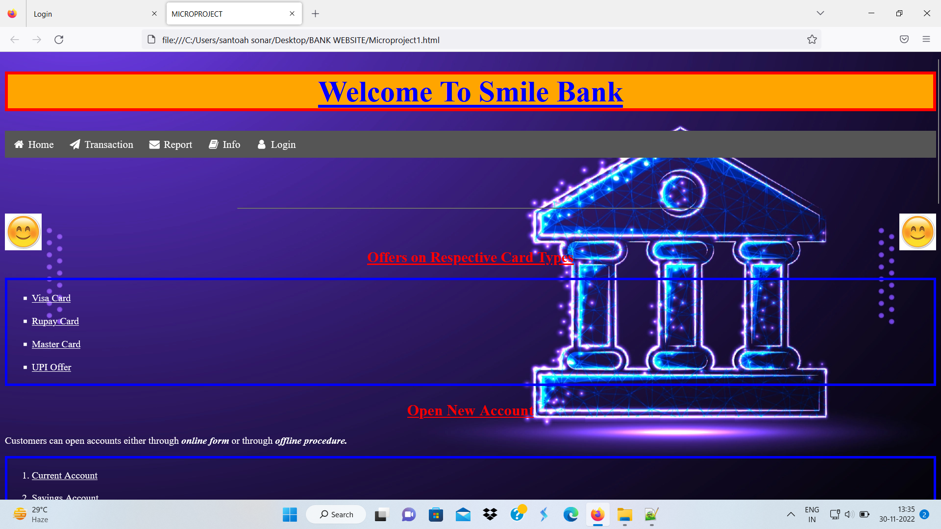

1. 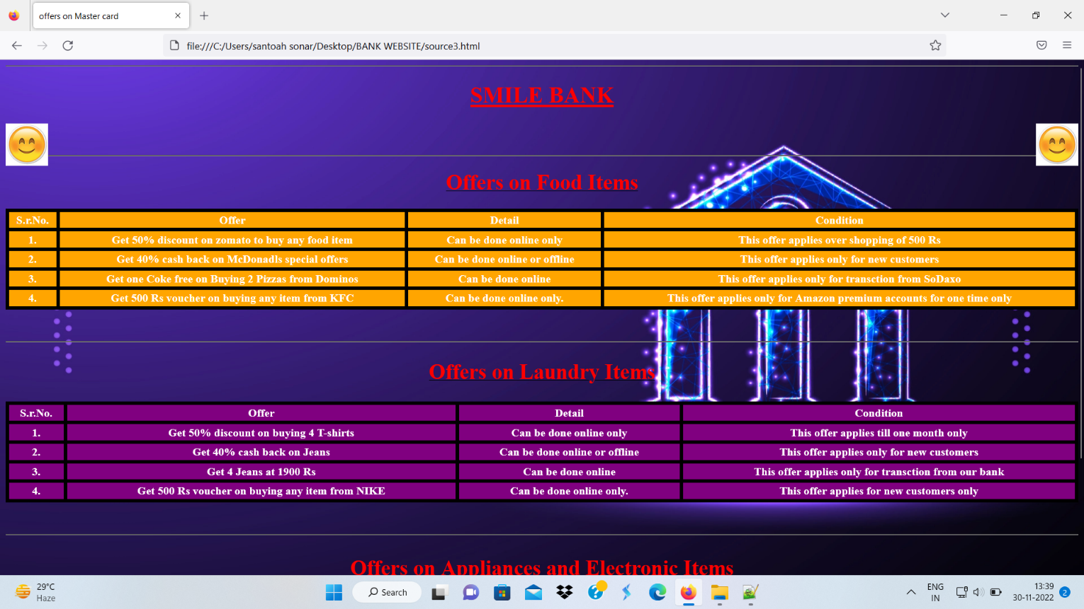Account Benefits Page
2. 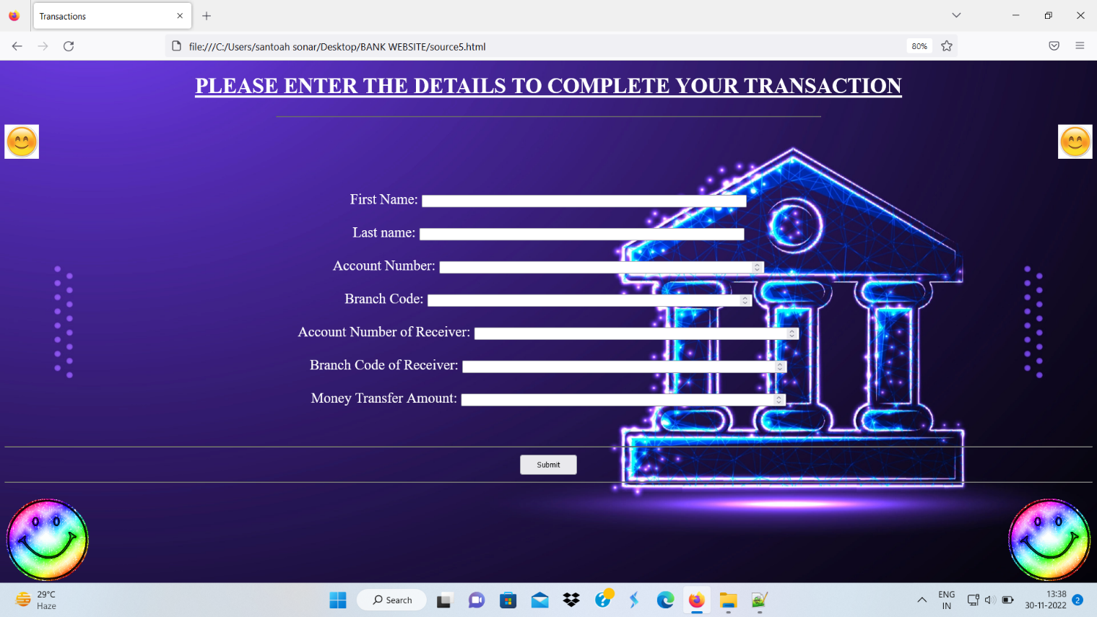Transaction Page Using FORM elements
3. 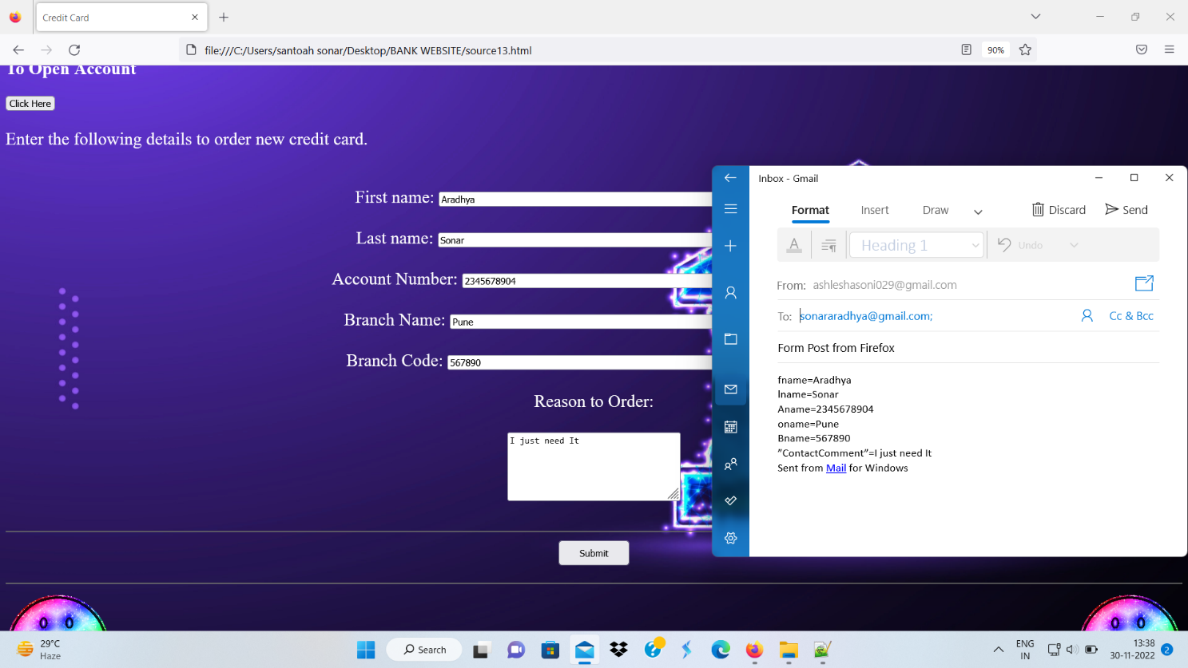Website with Mail to Feature
4. Web Pages for Card Order (Credit, Debit, Prepaid)

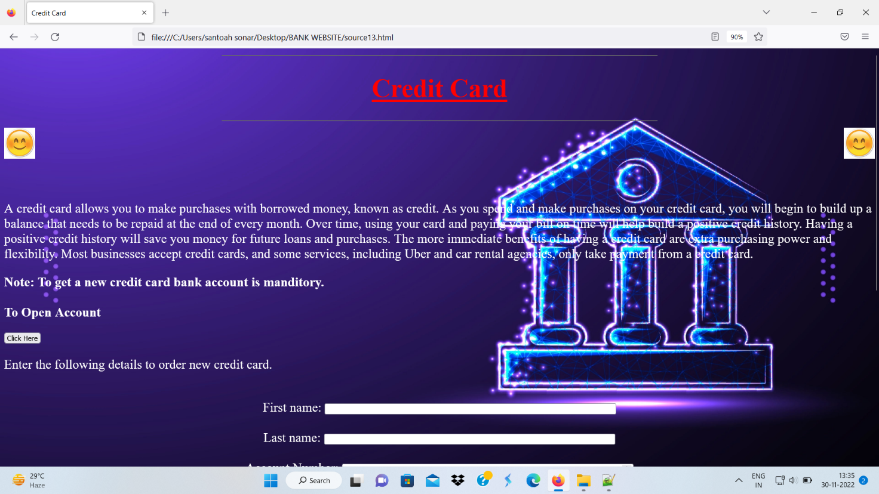

1. 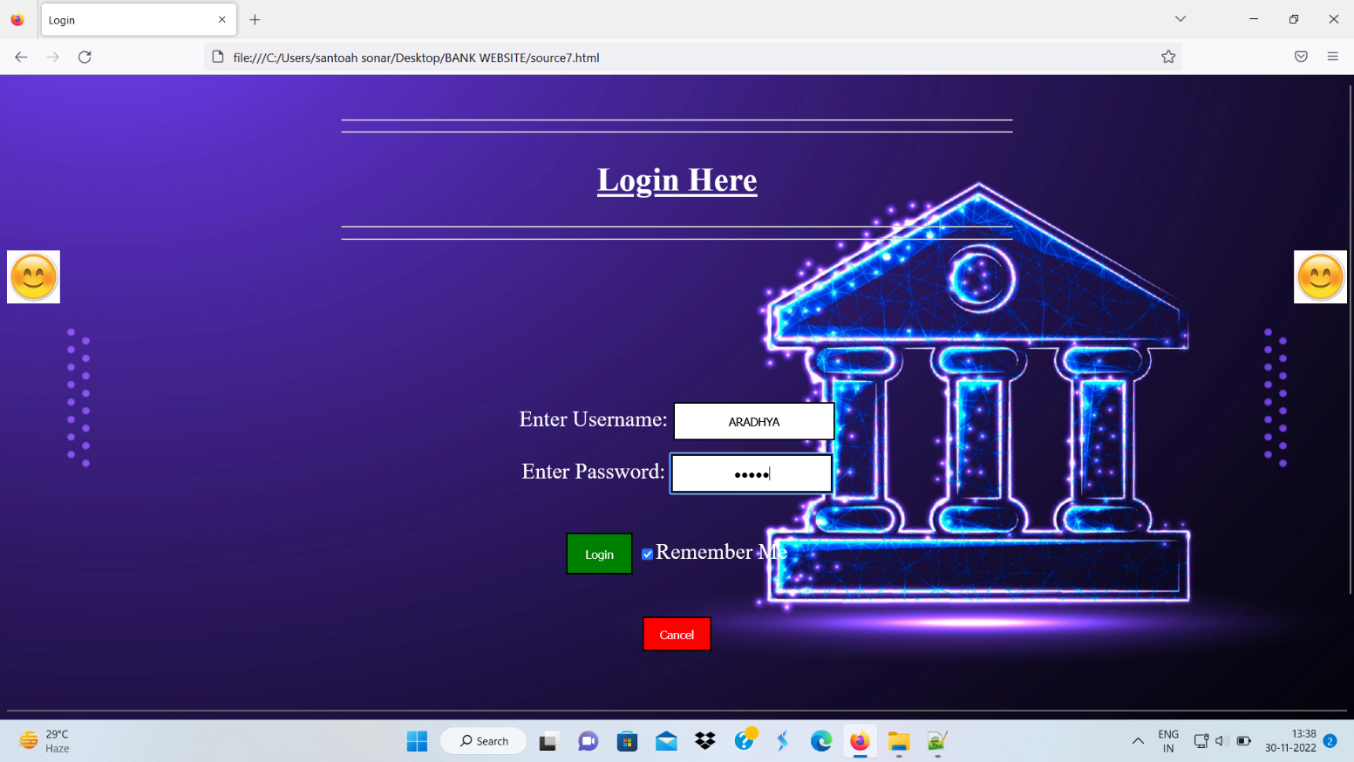Login Page Using FORM Elements
2. 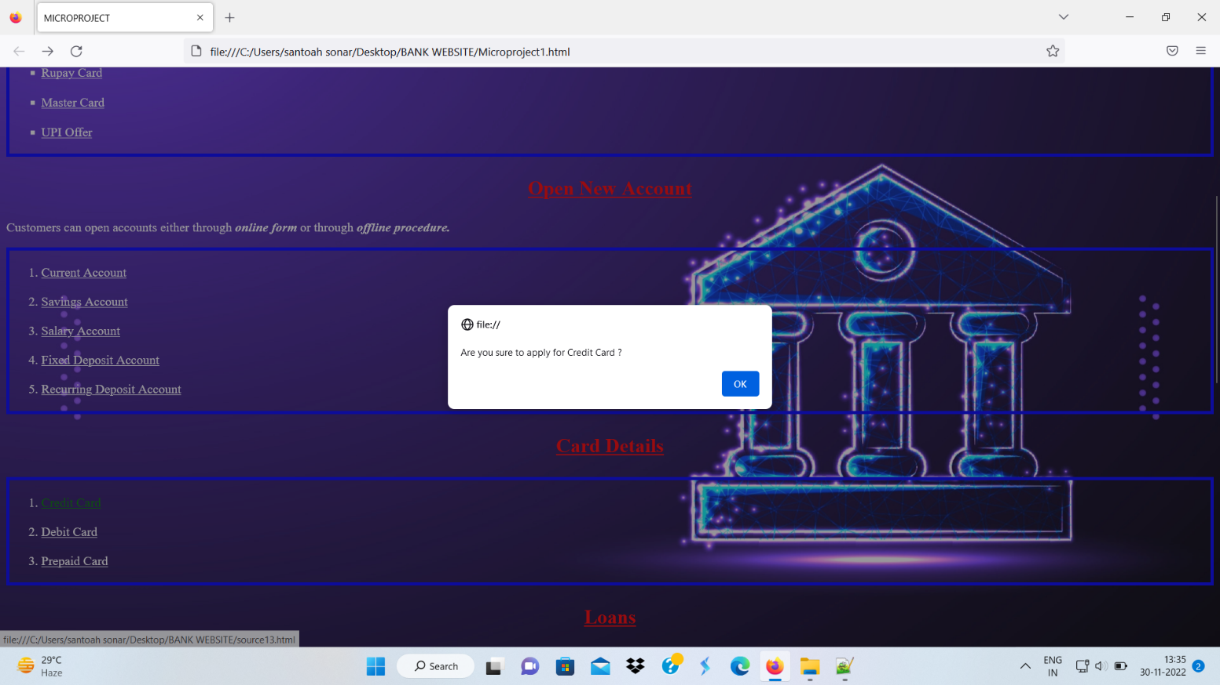Event Handling Using OnClick
3. 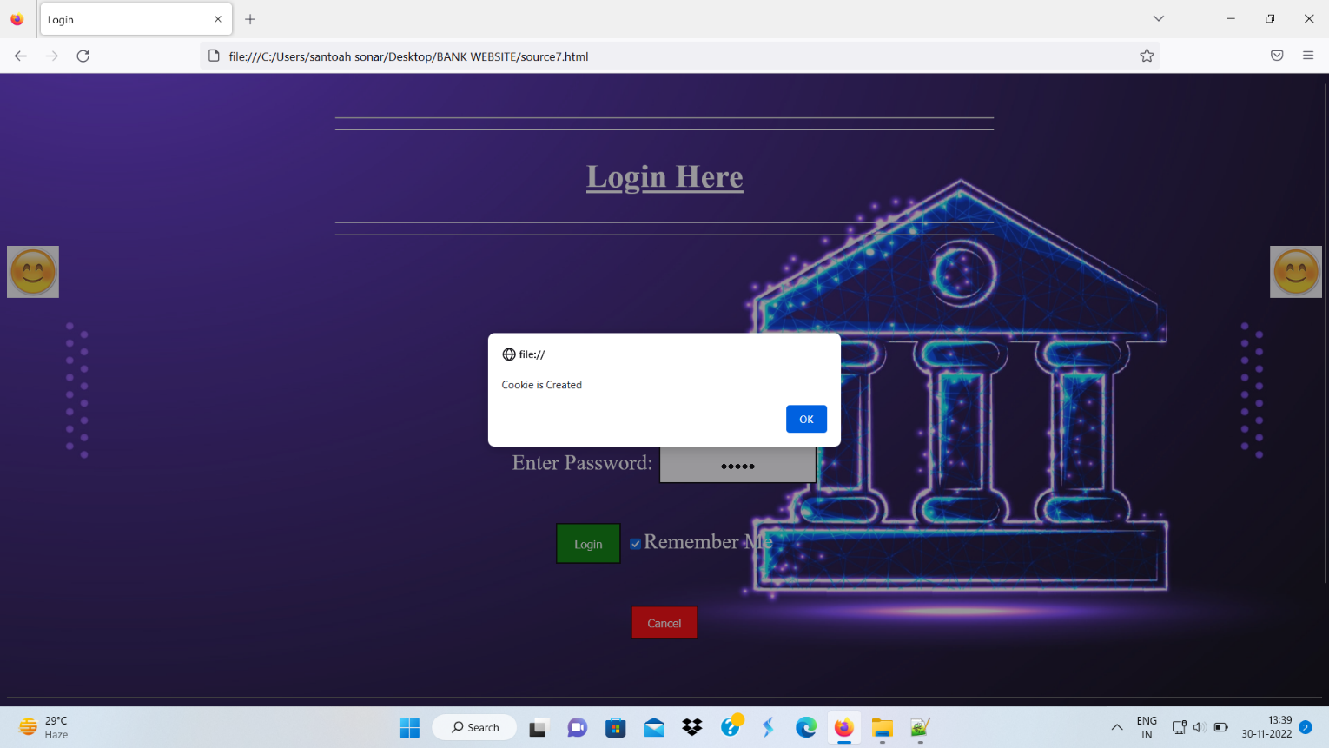Cookie Creation and Display

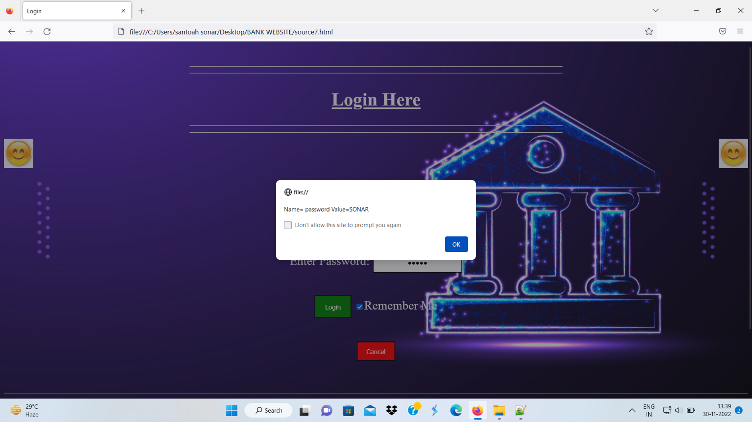

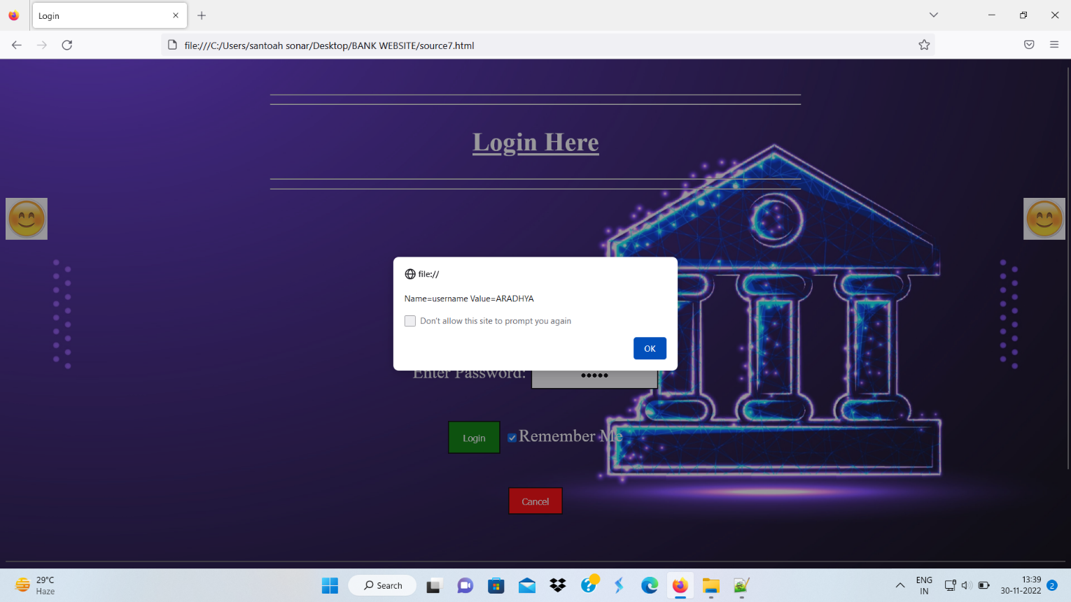

1. 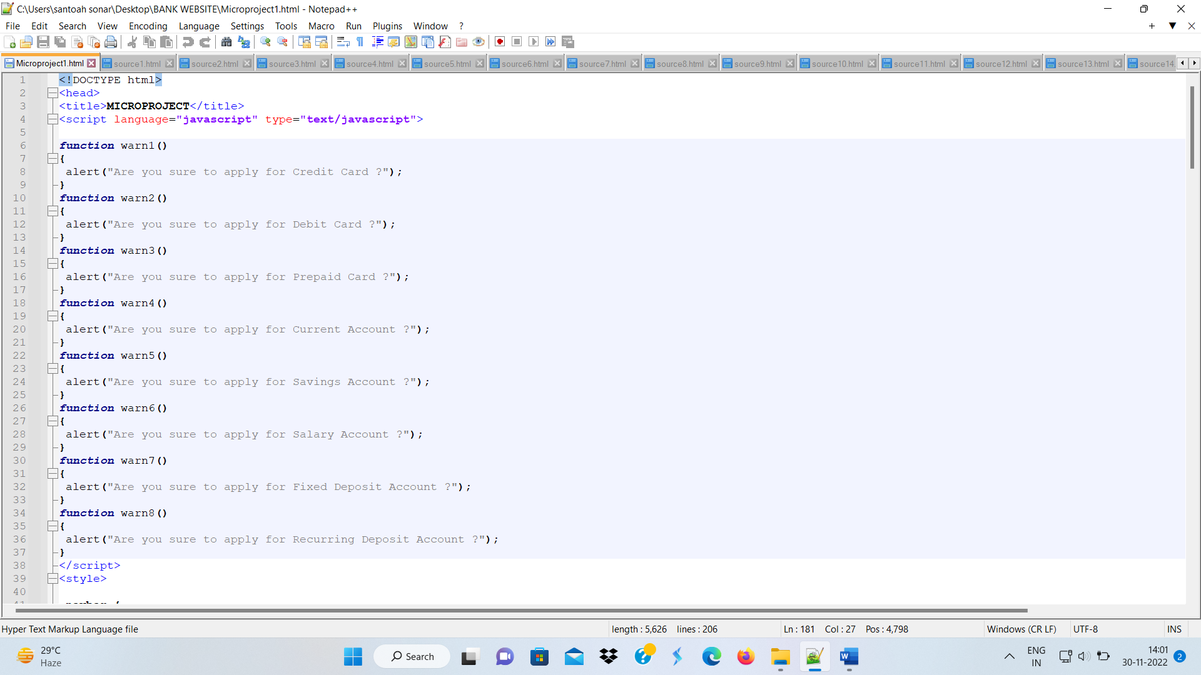Using Function
2. 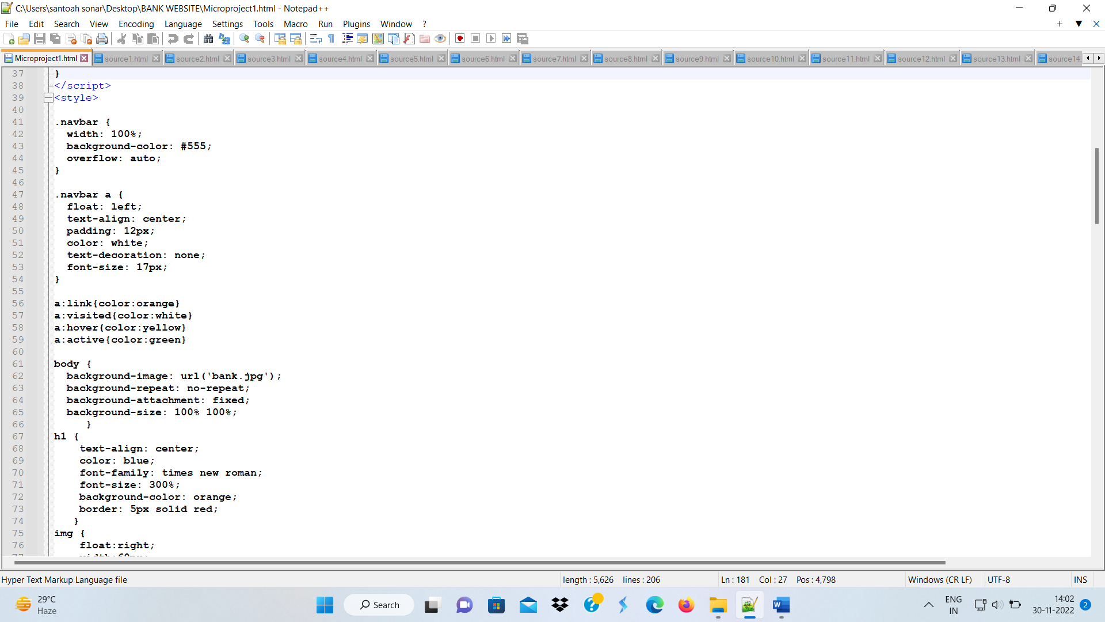Added Navbar Using CSS
3. Website with Regular Expression Implementation

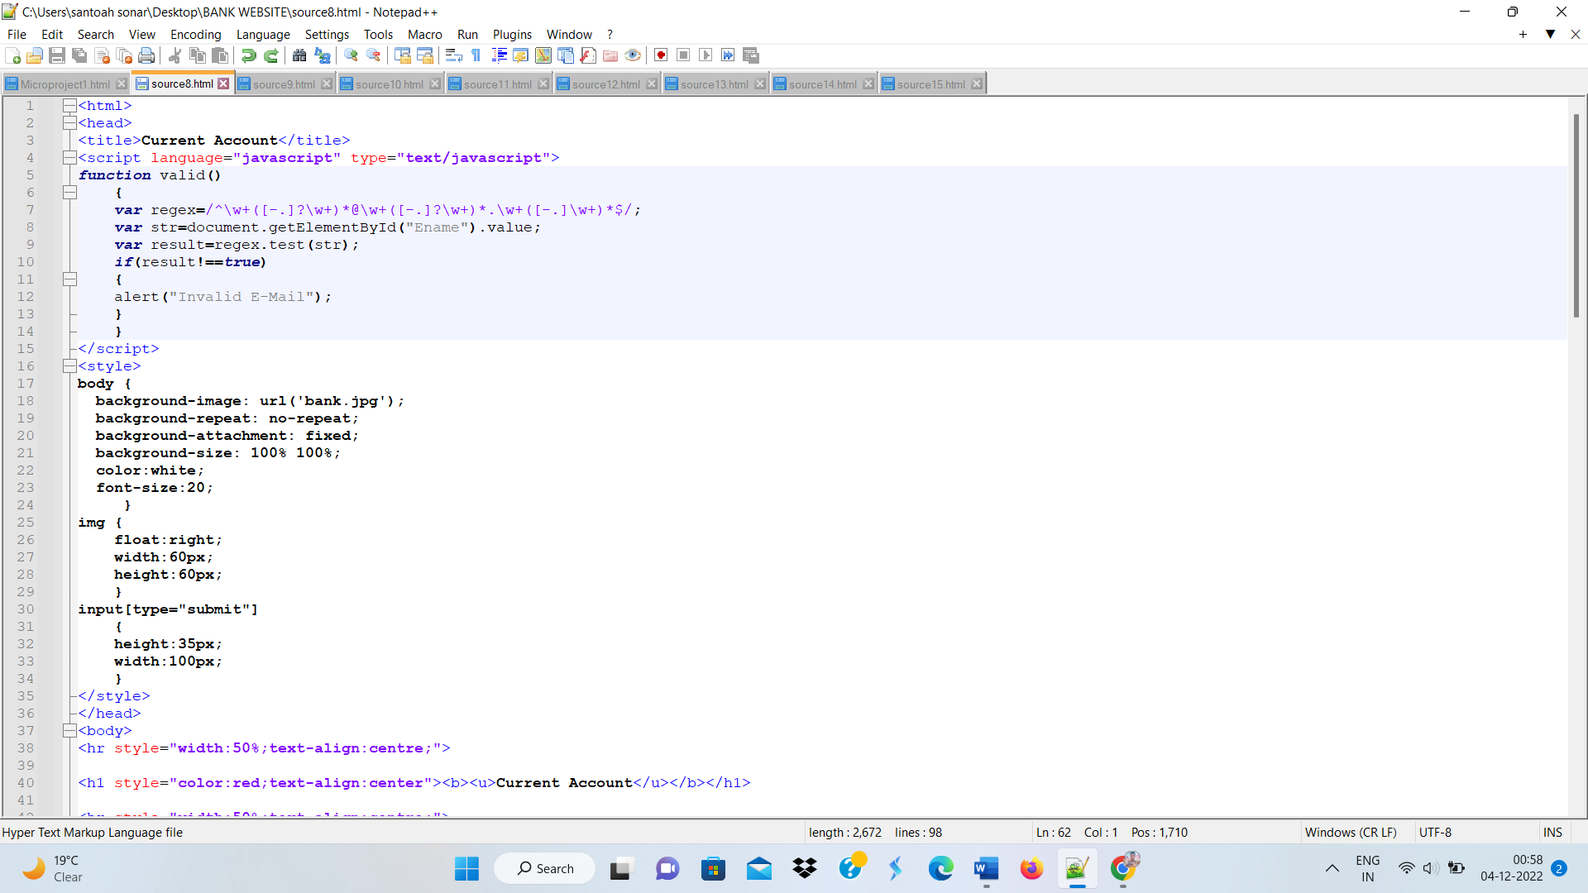

1. Opened new window using window.open()

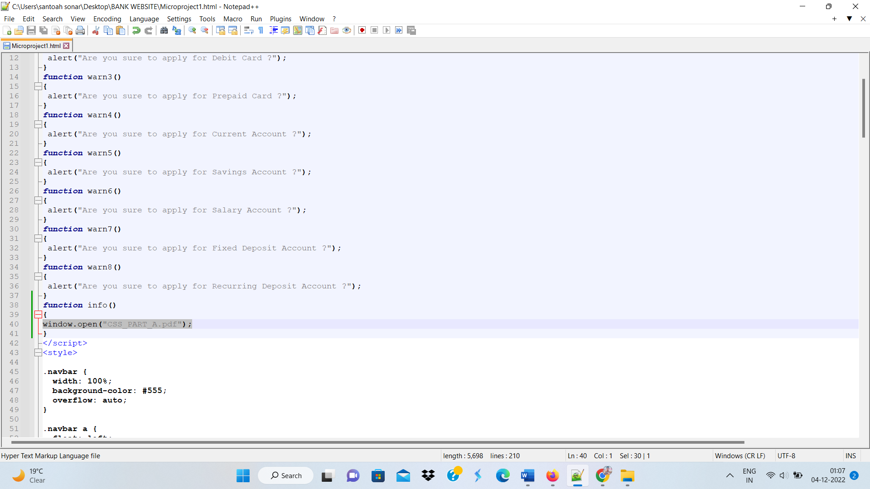

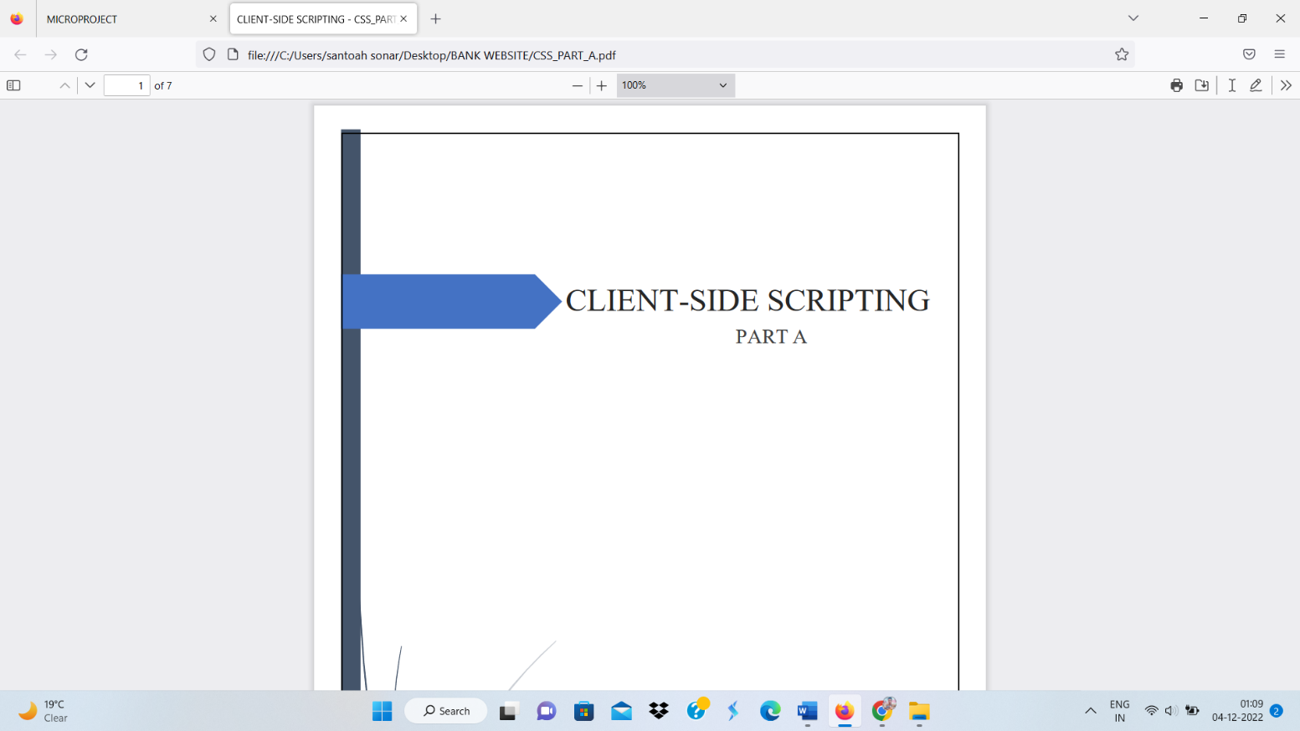

* **Applications of this Micro-Project**

JavaScript is commonly used for creating web pages. It allows adding dynamic behaviour to the webpage and adding special effects to the webpage.

* **Area of Future Improvement**

We have developed webpage with basic JavaScript functionalities. In future we would like to add various additional features to our webpage.

* **Names of Team Members.**

|  |  |  |  |
| --- | --- | --- | --- |
| **Sr. No.** | **Names of Group Members** | **Roll No.** | **Enrollment No.** |
| 1 | Aradhya Santosh Sonar | 22IF344 | 2010510394 |
| 2 | Kajal Subhash Sarode | 22IF340 | 2010510388 |
| 3 | Siddhi Balasaheb Kale | 22IF324 | 2010510372 |
| 4 | Shedage Shubham Kalyan | 22IF370 | 2010510389 |
| 5 | Sanika Rajandra Hule | 22IF317 | 2010510363 |

**Group Leader: Aradhya Santosh Sonar**

**(Name & Signature of faculty)**

**Date : - / / 2022**